Register Number: _____________________

DHANALAKSHMI SRINIVASAN ENGINEERING COLLEGE, PERAMBALUR – 621 212
(AUTONOMOUS)

DEPARTMENT OF AERONAUTICAL ENGINEERING

U20AE502/ Aircraft Structures
ASSESSMENT TEST – II
Year /Semester: III / V Date:
Duration: 90 minitues Total Marks: 60
Part A: 10 X 2 = 20 Marks
Answer all the questions
1 | Explain a concept of stiffened panel? | 2 | CO3 | BTL2
2 | List out the buckling modes of a thin walled section. | 2 | CO3 | BTL2
3 | Write the assumptions of plate theory? | 2 | CO3 | BTL2
4 | Define stress resultants. | 2 | CO3 | BTL2
5 | What is Bredt-Batho formula? | 2 | CO3 | BTL2
6 | What is semi tension field beam? | 2 | CO4 | BTL2
7 | Define Shear Centre and Shear Flow. | 2 | CO4 | BTL2
8 | Define Shear stress. | 2 | CO4 | BTL2
9 | Write the formulas for moment of inertia? | 2 | CO4 | BTL2
10 | Mark shear centre for thin walled equal angle section and T-section. | 2 | CO4 | BTL2

Part B: 2 X 13=26; 1X14=14=40 Marks
Answer all the questions
11 | a | i | Determine the shear flow distribution in the thin-walled Z section as shown in figure, due to a shear load Sy applied through the shear center of the section.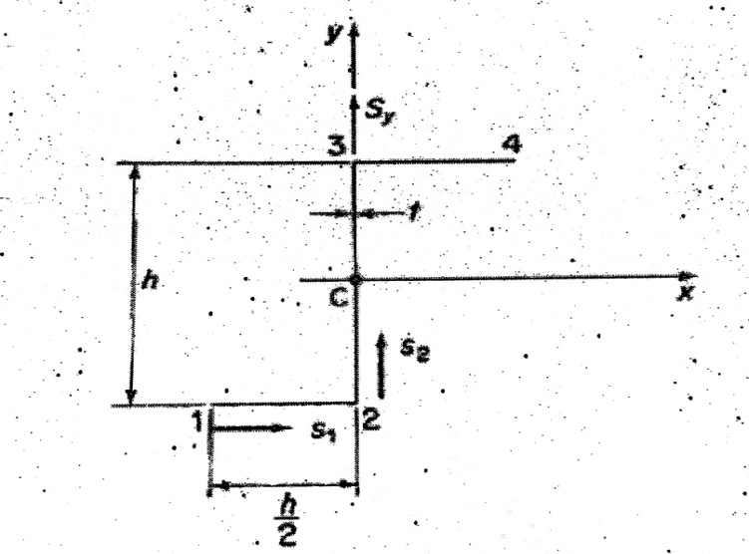 | 13 | CO3 | BTL3
11 | Or
11 | b | ii | A Find the Shear Flow Distribution and maxmimum shear flow.  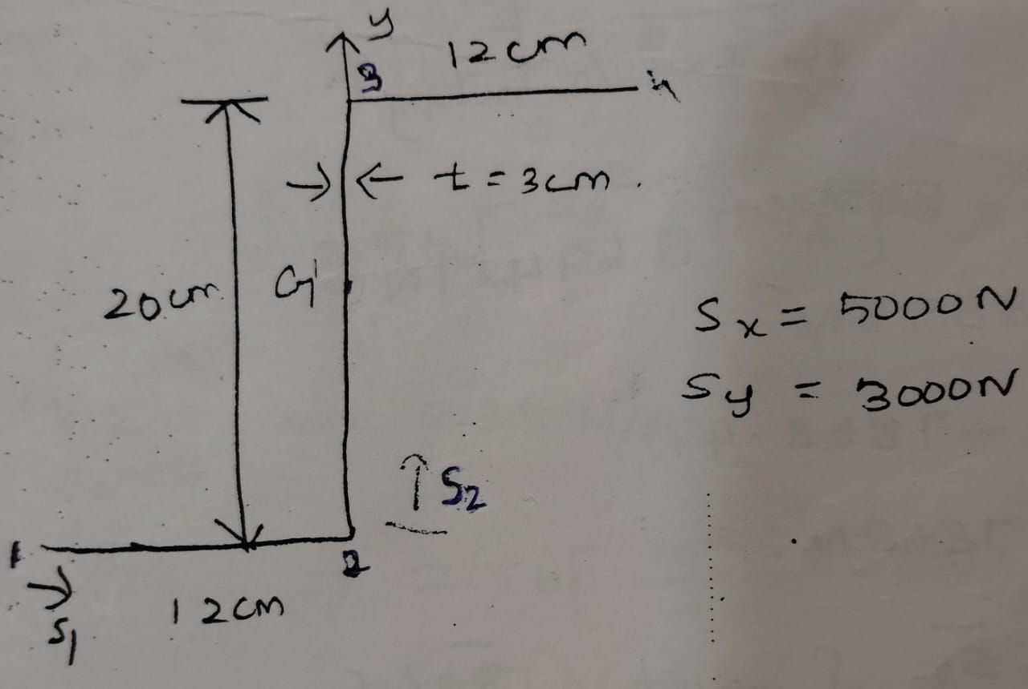 | 13 | CO3 | BTL4
12 | a | i | Plot the sher flow distribution given open section, Sx= 1200 N Sy= 1400 N through the shear center.Wall ineffective in bending.  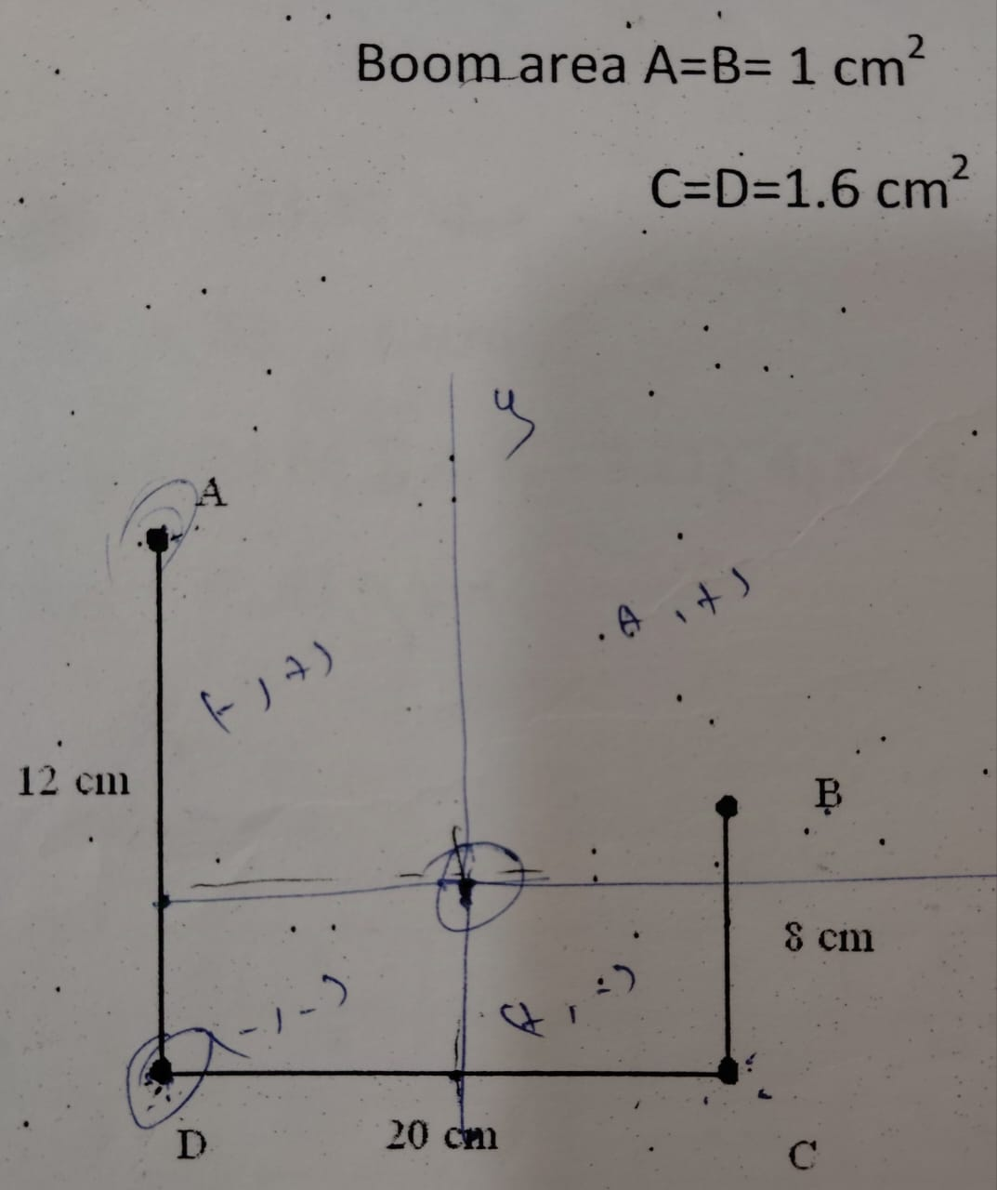 | 13 | CO3 | BTL4
12 | Or
12 | b | ii | Plot the shear flow distribution given open section a vertical load of 10 KN acts through the shear centre. Wall ineffective in bending.  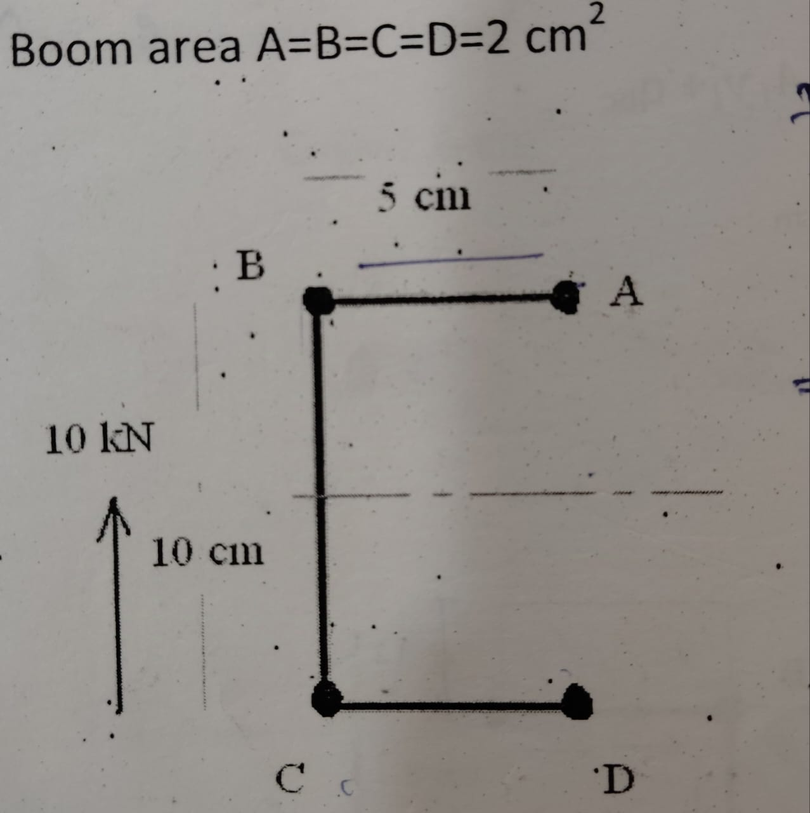 | 13 | CO3 | BTL4
13 | a | i | Find the shear flow for open section Shown in fig i) Find the line of action of the force so that the section doesnot rotate ii) Find the shear center of the section.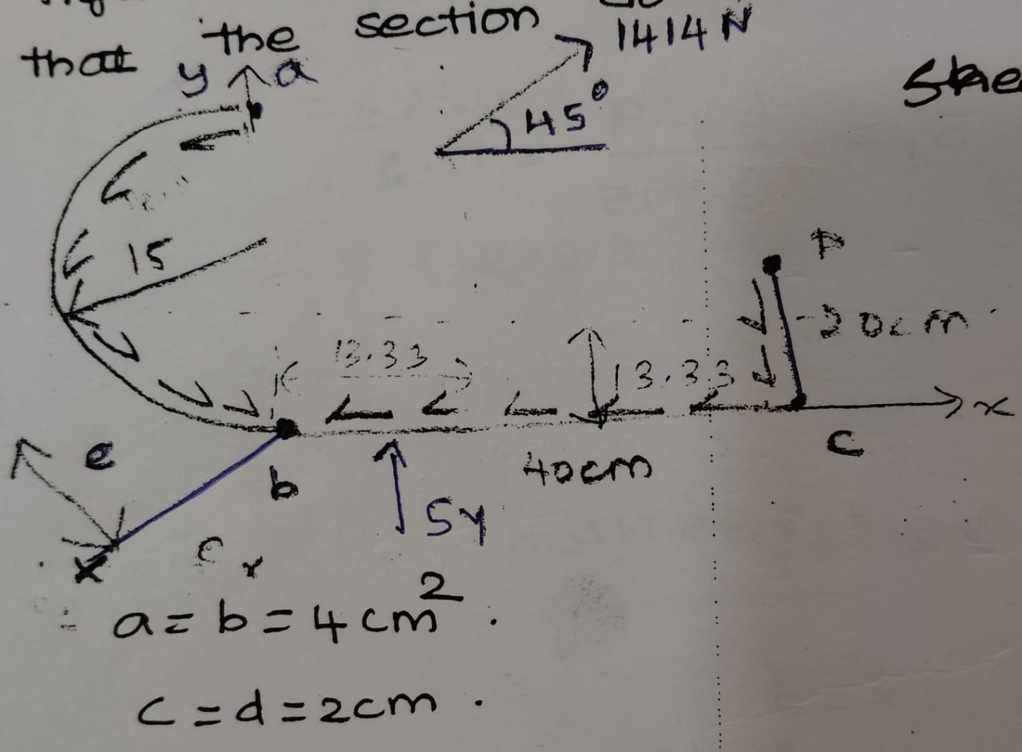 | 14 | CO4 | BTL3
13 | or
13 | b | ii | Derive an expression for determining the shear stress of an closed section beam. | 14 | CO4 | BTL3

Prepared by Verified by

